Title of Paper: Capitalize all “major” words (nouns, verbs, adjectives, adverbs, and pronouns) in the title and subtitle (Times New Roman 14 Bold)

First author^{a*}, Secound author^{b}, … (Times New Roman 12 Bold)

ª Department …, Faculty …, University … , City, Country. (Times New Roman 11)
^{b} Department …, Faculty …, University … , City, Country.
*Corresponding author: Full Name and Family name. Email: … , ORCID: …

Article Info | ABSTRACT (Times New Roman 12 Bold)
Article type: (Times New Roman 9 Bold)  Research Article  (Times New Roman 9)  Article history:  Received …  Received in revised form…  Accepted …  Available online …  (Times New Roman 9)  Keywords:  term 1,  term 2,  term 3,  term 4,  term 5.  Provide 5 keywords, separated by commas (,). (Times New Roman 9) | “An abstract is a brief, comprehensive summary of the contents of the paper. A well-prepared abstract can be the most important paragraph in an article. Many people have their first contact with an article by reading the title and abstract, usually in comparison with several others, as they conduct a literature search. Readers frequently decide on the basis of the abstract whether to read the entire article. The abstract needs to be dense with information. By embedding essential terms in your abstract, you enhance readers’ ability to find the article. This section addresses the qualities of a good abstract and standards for what to include in abstracts for different paper types” (Source: APA Publications Manual, 7 Edition, Section 3.3). (Times New Roman 9)  The word count of a short English abstract should be between 250 and 350 words. The English abstract of the article should also be structured and include the Objective, Method, Results, and Conclusions sections in a coherent paragraph.

Introduction (Font: 12 Times Bold)
(Font: 12 Times) The body of an article always opens with an introduction. The introduction contains a succinct description of the issues being reported, their historical antecedents, and the study objectives. The introduction of an article frames the issues being studied. Consider the various concerns on which your issue touches and its effects on other outcomes (e.g., the effects of shared storybook reading on word learning in children). This framing may be in terms of fundamental theory, potential application, input for public policy, and so forth. Proper framing helps set readers’ expectations for what the report will and will not include. State the importance of the research problem or question, including theoretical or practical implications.
- Frame the problem or question and its context.
- State the purpose(s)/goal(s)/aim(s) of the study.
- Review the background literature, and explicitly state the hypotheses being explored.
- Review, critique, and synthesize the applicable literature to identify key issues/debates/theoretical frameworks in the relevant literature to clarify barriers, knowledge gaps, or practical needs.
- State the target audience, if specific.
- Provide the rationale for fit of design used to investigate this purpose/goal (e.g., theory building, explanatory, developing understanding, social action, description, highlighting social practices).
- Describe the approach to inquiry, if it illuminates the objectives and research rationale

Journal of strategies of engineering sciences and sustainable systems management Journal of strategies of engineering sciences and sustainable systems management Journal of strategies of engineering sciences and sustainable systems management Journal of strategies of engineering sciences and sustainable systems management Journal of strategies of engineering sciences and sustainable systems management Journal of strategies of engineering sciences and sustainable systems (Table 1).

Table 1. Participant Demographics (Font: 10 Times Bold)
Demographic Element | Category | Frequency (n=92) | Percentage (%) | Notes / Observations
Gender | Female | 34 | 37% | Higher representation in NGOs and schools; cultural norms influenced participation in some countries (e.g., Yemen, Saudi Arabia).
Gender | Male | 58 | 63% | Predominantly in NGOs, universities, and government-affiliated initiatives.
Age Group | 21–30 years | 18 | 20% | Early-career educators and students involved in field-based projects.
Age Group | 31–40 years | 35 | 38% | Mid-career professionals, majority NGO and school educators.
Age Group | 41–50 years | 26 | 28% | Senior educators, university faculty, and program managers.
Age Group | 51+ years | 13 | 14% | Experienced leaders, often founding or coordinating long-term initiatives.

management Journal of strategies of engineering sciences and sustainable systems management Journal of strategies of engineering sciences and sustainable systems management Journal of strategies of engineering sciences and sustainable systems management Journal of strategies of engineering sciences and sustainable systems management.

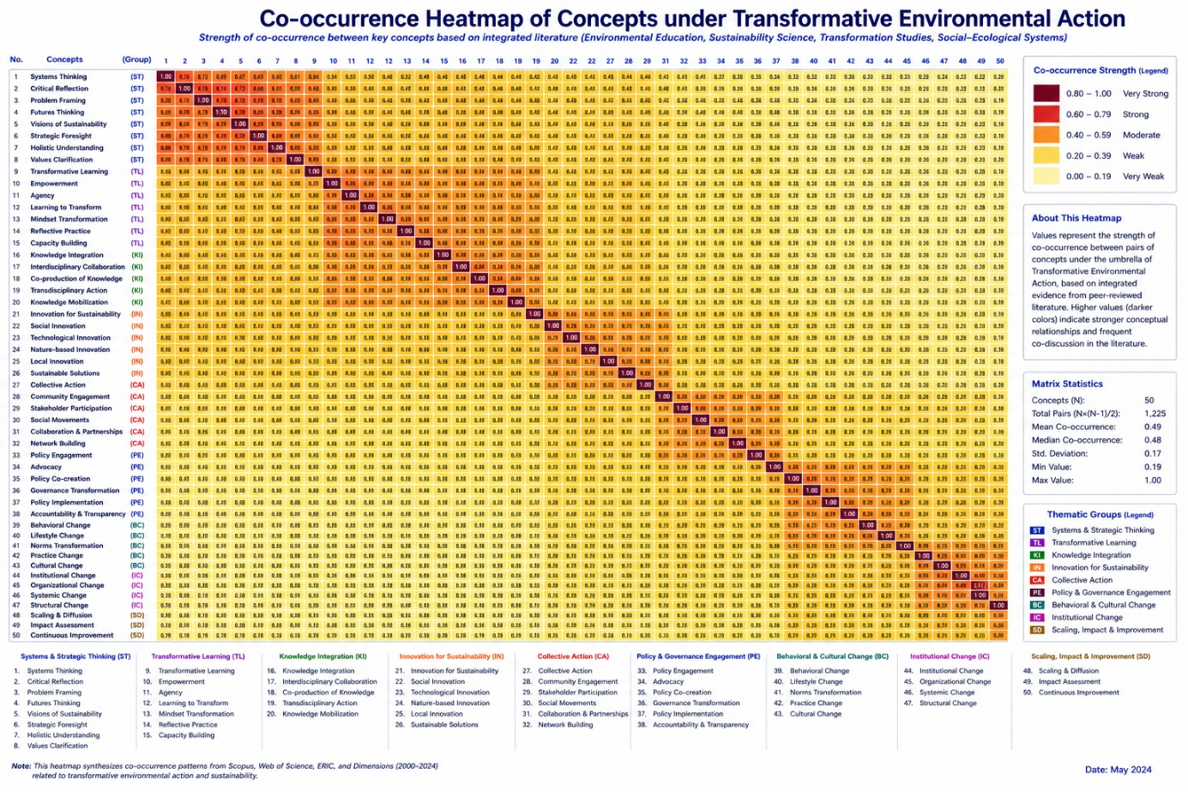
Figure 1. Co-occurrence heatmap of transformative action concepts (Font: 10 Times Bold)

Method (Font: 12 Times Bold)
(Font: 12 Times) Describe the study method, including
- research design (e.g., experiment, observational study)
- sample size
- materials used (e.g., instruments, apparatus)
- outcome measures
- Data-gathering procedures, including a brief description of the source of any secondary data. If the
- Study is a secondary data analysis, so indicate.
- a full description of each step of the investigation, including details about the materials used and the procedures followed (which should be sufficient to enable replication);
- A full statement of the research design, statements on the protection of human participants or nonhuman animal subjects and informed consent, and a description (in words and/or a figure) of the flow of participants through the study.
Journal of strategies of engineering sciences and sustainable systems management Journal of strategies of engineering sciences and sustainable systems management Journal of strategies of engineering sciences and sustainable systems management Journal of strategies of engineering sciences and sustainable systems management Journal of strategies of engineering sciences and sustainable systems management Journal of strategies of engineering sciences and sustainable systems management Journal of strategies of engineering sciences and sustainable systems management.

Results (Font: 12 Times Bold)
(Font: 12 Times) In the Results section of a quantitative paper, summarize the collected data and the results of any analyses performed on those data relevant to the discourse that is to follow. Report the data in sufficient detail to justify your conclusions. Mention all relevant results, regardless of whether your hypotheses were supported, including results that run counter to expectation; include small effect sizes (or statistically nonsignificant findings) when theory predicts large (or statistically significant) ones. Do not hide uncomfortable results by omission. In the spirit of data sharing, raw data, including study characteristics and individual effect sizes used in a meta-analysis, can be made available as supplemental materials or archived online. However, raw data (and individual scores) generally are not presented in the body of the article because of length considerations. Analyze data and report findings, including effect sizes and confidence intervals or statistical significance levels.
Journal of strategies of engineering sciences and sustainable systems management Journal of strategies of engineering sciences and sustainable systems management Journal of strategies of engineering sciences and sustainable systems management Journal of strategies of engineering sciences and sustainable systems management Journal of strategies of engineering sciences and sustainable systems management Journal of strategies of engineering sciences and sustainable systems management Journal of strategies of engineering sciences and sustainable systems management

Conclusions (Font: 12 Times Bold)
(Font: 12 Times) State conclusions, beyond just results, and report the implications or applications. In the conclusion, consider returning to a discussion of why the problem is important (as stated in the introduction); what larger issues, meaning those that transcend the particulars of the subfield, might hinge on the findings; and what propositions are confirmed or disconfirmed by the extrapolation of these findings to such overarching issues. Also consider the following issues:
- What is the theoretical, clinical, or practical significance of the outcomes, and what is the basis for these interpretations?
- If the findings are valid and replicable, what real-life psychological phenomena might be explained or modeled by the results?
- Are applications warranted on the basis of this research?
- What problems remain unresolved or arise anew because of these findings?
The responses to these questions are the core of the contribution of your study and justify why readers both inside and outside your specialty should attend to the findings. Readers should receive clear, unambiguous, and direct answers.
Journal of strategies of engineering sciences and sustainable systems management Journal of strategies of engineering sciences and sustainable systems management Journal of strategies of engineering sciences and sustainable systems management Journal of strategies of engineering sciences and sustainable systems management Journal of strategies of engineering sciences and sustainable systems management Journal of strategies of engineering sciences and sustainable systems management Journal of strategies of engineering sciences and sustainable systems management

References (Font: 12 Times Bold)
(Font: 12 Times) All publications cited in the text should be presented in the list of references following the text of the manuscript. In the text, refer to the authors' name (without initials) and year of publication (e. g. Williams, 2004). For three or more authors, use the first author followed by "et al.," in the last. The list of references at the end of the manuscript should be arranged alphabetically by authors' names and chronologically per author. Only sources used in the text should be cited at the end of the article. The minimum standard for references used in articles is 30. The list of references should be given in the following style (APA style):

1. Journal article:
Boroumand, A., Amiri, M. J., & Faryadi, S. (2026). An Analysis of Eco-Emotions Among Iranian Students in Environmental Education. International Journal of Environmental Research, 20(1), 54.‏ https://doi.org/10.1007/s41742-025-01001-4

2. Book chapter:
Cutrona, C. E. and Russell, D. Eds. (1990). Type of social support and specific stress: Towards a theory of optimum matching. (In I.G. Sarason, B. R. Sarason, & G. Pierce (Eds.), Social support: An interactional view (pp. 341-366). New York: Wiley.)
3. Book, authored:
Fang, W. T., Hassan, A. A., & LePage, B. A. (2023). The living environmental education: Sound science toward a cleaner, safer, and healthier future (p. 279). Springer Nature (Springer Singapore). Singapore. Singapore‏ https://doi.org/10.1007/978-981-19-4234-1
4. Book, edited:
Felner, R. D., Jason, L. A., Moritsugu, J. N. and Farber, S. S. (Eds.) (1983). Preventive psychology: Theory, research and practice. (New York: Pergamon Press)
5. Conference papers:
Phelan, J. C., Link, B. G., Stueve, A. and Pescosolido, B. A. (1996, November). Have public conceptions of mental health changed in the past half century? Does it matter? (Paper presented at the 124th. Annual Meeting of the American Public Health Association, New York)
6. Dissertation:
Trent, J.W. (1975) Experimental acute renal failure. Dissertation, University of California
7. Internet publication/Online document
7.1. Internet articles based on a print source
VandenBos, G., Knapp, S., & Doe, J. (2001). Role of reference elements in the selection of resources by psychology undergraduates [Electronic version]. J. Bibliog. Res., 5, 117-123.
VandenBos, G., Knapp, S., & Doe, J. (2001). Role of reference elements in the selection of resources by psychology undergraduates. J. Bibliog. Res., 5, 117-123. Retrieved October 13, 2001, from http://jbr.org/articles.html.
7.2. Article in an Internet-only journal
Fredrickson, B. L. (2000, March 7). Cultivating positive emotions to optimize health and well-being. Prevention & Treatment, 3, Article 0001a. Retrieved November 20, 2000, from http://journals.apa.org/prevent/vol3/pre03.html.
Important:
- It is recommended to all authors to mention the corresponding author form faculty members of universities.
- Please check the ORCID and Email address of Corresponding author before submission.
- Regarding the names of plant and animal species, the first mention in the text should follow this format: English name (scientific name in italics); subsequently, citing the English name alone will suffice.
- Maximum page numbers of manuscripts are 15 pages.
- All tables and figures should be explicitly referred to in the main text.
- All photographs, graphs, and diagrams should be referred to as a 'Figure,' and they should be numbered consecutively (1, 2, etc.).
- Multipart figures ought to be labeled with lowercase letters (a, b, etc.).
- Please insert keys and scale bars directly in the figures. Provide a detailed legend (without abbreviations) to each figure, refer to the figure in the text, and note its approximate location in the margin.
- Figures should be submitted in separate files. The resolution of each figure must be at least 300 dpi. jpg and tiff files are accepted. Figures that are prepared by Excel should be sent along with their source of data.
- Each table should be numbered consecutively (1, 2, etc.).
- Please provide a caption (without abbreviations) to each table, refer to the table in the text, and note its approximate location in the manuscript.
- The same data should not be presented simultaneously in tables and figures.
- If the content of tables and figures is derived from or belongs to other authors, copyright and authors’ rights must be respected by providing an accurate reference to the original source.

Review process
The objective is to provide detailed, constructive feedback on submitted papers and publish high-quality papers within a very short period of time. The target for a first reply is three months. You may be requested by the Editor to submit a revision. Please assist us in achieving our ambitious goals for short publication times by submitting a revision at your earliest convenience.

Copyright
Authors will be asked, upon acceptance of an article, to transfer copyright of the article to the Publisher. This will ensure the widest possible dissemination of information under copyright laws.
The submitted materials may be considered for inclusion, but can not be returned.

Note
Editors of the Journal reserve the right to accept, reject, and edit any article at any stage, if necessary. The sole responsibility for the whole contents if the article published, remains only with the authors. Published papers can not be withdrawn from the Journal.

